Student: Joseph Roper

Salford City College |

BTEC National 90 Credit Diploma in Creative Media Production

Unit 74: Computer Games story development

Contents

Forms of Storytelling 2

Myths 2

Cave Paintings 3

Legends 3

Books 4

Graphic Novels/ Comics 4

Films & Television 4

Games 5

Theatre 5

Music & Poetry 5

Game Genres 6

First Person Shooter (FPS) 6

Role Playing Games (RPG) 7

Fighting 7

Sport 8

Strategy 8

Simulation 9

Story Devices 10

Location 10

Conditions and Actions 11

Symbolism 11

Three Act Structure 11

Hero’s Journey 12

Episodic 13

Representation 13

Emotion 13

Characterisation 14

Stereotyping 14

Resources 16

# Forms of Storytelling

## Myths

A myth is a story that is most often about the creation of the world, or about Gods/Goddesses and higher beings, or mythical characters (mythical meaning made up and almost completely unbelievable). Myths originate from Ancient Greek times also, and although they have no truth to them, they are an opinion on the creation and existence of this world. An example of such a story would be The Minotaur, or Medusa. Both including mythical creatures and Higher beings.

An example of a widely popular ancient myth is that of the great demigod Hercules born from the heavens and sent down to earth his farther is the great god Zeus and he even has a pet Pegasus this myth stems from Ancient Greek Mythology and is about Hercules a demi god trying to prove to his farther that he can be a God to get back into heaven by performing a bunch of tasks to make him a hero such as by killing a massive lion. This story of Hercules becoming a hero is so popular that it has been turned into two films one animated and the other live action.

[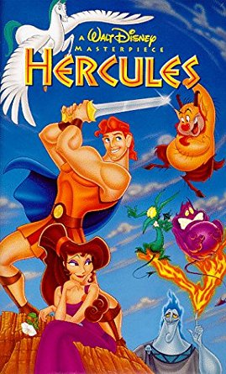](https://www.amazon.com/Hercules-Walt-Disney-Masterpiece-VHS/dp/0788805843)[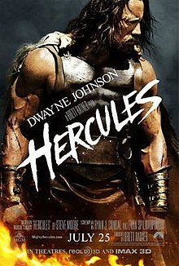](https://en.wikipedia.org/wiki/Hercules_(2014_film))

A new genre of modern myths is known as creepy pasta which became widely popular from 2011 onwards. An example of a creepy pasta is Hypno's lullaby: it is about a Pokémon from the game series who allegedly lures in children with this lullaby then hypnotises them to follow him into a cave and then the children will never be seen again, the myth is disturbing making it a relief that it is just fantasy. This is the lullaby: <https://www.youtube.com/watch?v=iDDv0TjFHXI>

[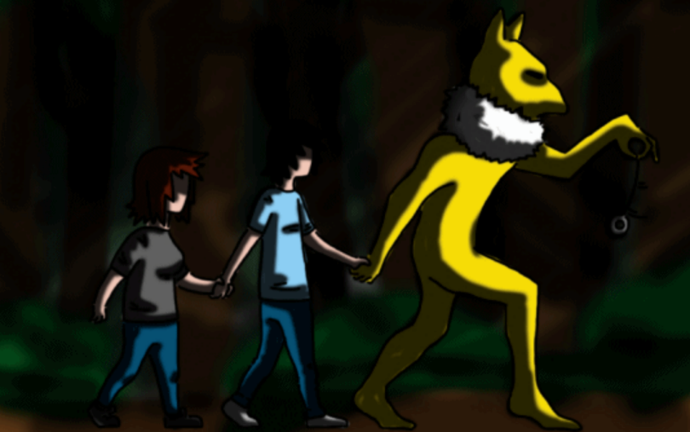](http://knowyourmeme.com/memes/hypnos-lullaby)

## Cave Paintings

Cave paintings were a common form of storytelling roughly around 40,000 years ago as recently found by archaeologists and is now known to be one of the first forms of storytelling of which we know of. The most well-kept cave painting that I know of is of many paintings of Bulls commonly known as the “Hall of the Bulls” which was found in the Lascaux Cave in France.

[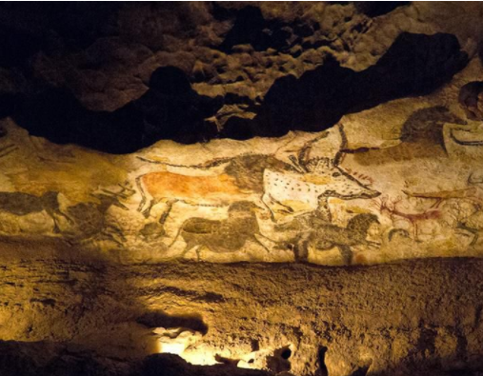](https://www.smithsonianmag.com/science-nature/rockart-ages-indonesian-cave-paintings-are-40000-years-old-180952970/?q=)The purpose of cave paintings is a debatable issue as some say it was used to depict religion and spread it across the world while others think it was used as a simple method of communication for example with this piece it says that the cavemen hunted these animals. While I agree with the second point I also believe that cavemen painted for fun like people do today such as a school pupil doodling in the corner of their book to pass the time, so while the males were hunting and there were no fruit and berries to gather they drew on the walls.

## Legends

Legends are similar to myths although the difference is that legends are passed down through tradition and other various forms of storytelling such as books. An example of an ancient legend is Jesus his stories of how he turned water into wine and providing a meal for 200 people with a little bit of fish and bread were passed down by family to family through tradition such as Christians going to church every Sunday and listening to passages out of the Bible.

[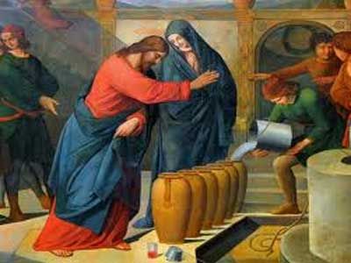](https://www.google.co.uk/url?sa=i&rct=j&q=&esrc=s&source=images&cd=&ved=0ahUKEwjrwui6_e3YAhWS6KQKHYlNCW8QjxwIAw&url=http://www.beliefnet.com/prayables/scripture/jesus-turns-water-into-wine-john-2.aspx?p%3D6&psig=AOvVaw39KMyncDyHQd4Uv42PLS4E&ust=1516793264654623)[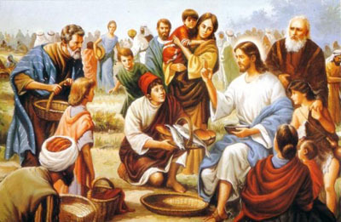](http://www.hipswellparish.org.uk/printer-friendly.php?page_id=146)[](http://www.3benefitsof.com/3-benefits-of-reading-the-bible/)

An example of a modern type of legend is urban legends. Urban legends can be both myths and legends as they are usually passed down by families or certain people of an area often containing the supernatural.

## Books

Books are one of the most common forms of storytelling and for good reason as it is effective as it can range from stories of fiction to non – fiction. Books have many ways of telling a story one of these if “Decide Your Destiny” where the book will give you options in which you will have to choose which path you go down effecting the story. Another form of storytelling within books is “Narration” this is when someone tells you about a previous event and what happened.

[](http://www.listchallenges.com/a-life-in-books)

## Graphic Novels/ Comics

Graphic Novels and Comics are basically books with a lot of pictures to display clearly what is happening in the story. Comics started becoming popular around the 1940’s to 1950’s with teenagers and children as comics usually contained everyone’s favourite superheroes such as superman.

[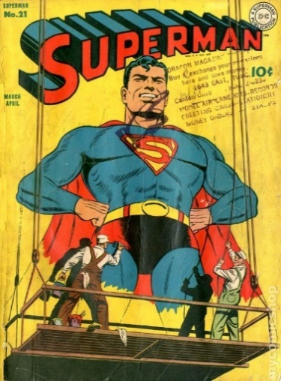](https://www.mycomicshop.com/search?TID=22601073)

## Films & Television

Film and television was the next step from books and theatre to represent storytelling. Most people prefer this form of media over others as it can really immerse someone into a story when watching it your favourite characters play out their lives on a screen. An example of this is Super girl as I prefer the television series over the comics as it makes the character seem more realistic and human (even though she’s an alien) which I believe creates a better experience for the audience.

[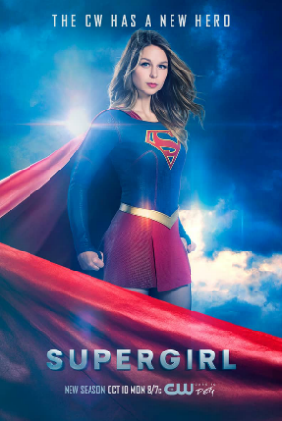](http://arrow.wikia.com/wiki/File:Supergirl_season_2_poster_-_The_CW_Has_a_New_Hero.png)[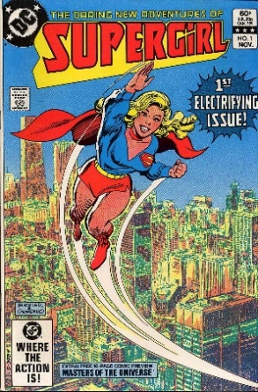](http://superman.wikia.com/wiki/Supergirl_(comic_book))

## Games

Games are a quite recent form of storytelling compared to all the other methods. Video games provide a more interactive form of storytelling making it popular as it gives a unique experience. Like all forms of storytelling there are many different genres of games, my favourite genre of games are platformers for example a recently new game I just completed called Celeste. It provided a fun while frustrating experience as I tried to climb a mountain as the main character Madeline deals with depression.

[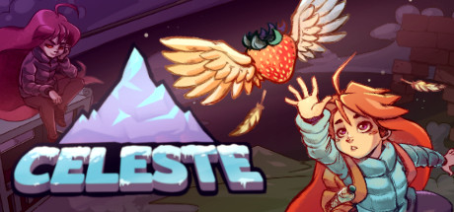](http://store.steampowered.com/app/504230/Celeste/)

## Theatre

Theatre has always been a very popular form of storytelling with all the big-ticket shows selling out. A form of theatre is the pantomime this genre is special as it takes why the theatre is popular and amplifies it by the actors on stage speaking to the audience which creates a connection between the performers and the audience.

## Music & Poetry

Stories are usually hidden in poetry or music and are not explicitly mentioned to the audience. A good example of this is from the song “Good Day” by Nappy Roots, in the song it tells us about this black neighbourhood which is suffering from gang violence you can tell this from the lyrics as the school girls sing:

And ain't nobody gotta cry today  
'Cause ain't nobody gonna die today  
You save that drama for another day

From this we see that people are getting killed on the streets daily and that everyone who is killed is part of the neighbourhood as it affects everyone resulting in girls crying.

[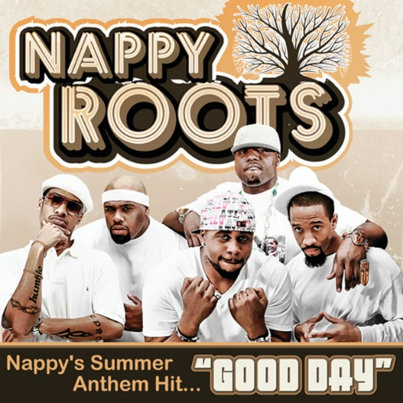](https://open.spotify.com/track/4cnqxdE2opmhp7MwkvhkAJ)

<https://www.google.co.uk/search?q=nappy+roots+good+day+lyrics&rlz=1C1DSGP_enGB548GB548&oq=nappy+roots+good+day+lyrics&aqs=chrome..69i57j0l5.8911j0j7&sourceid=chrome&ie=UTF-8>

# Game Genres

## First Person Shooter (FPS)

First person shooters are games that involve the player holding a gun and shooting their way to victory. This is the most popular genre of games currently and most games in this genre are clones of one another but sometimes there comes a game in this genre that really stands out.

[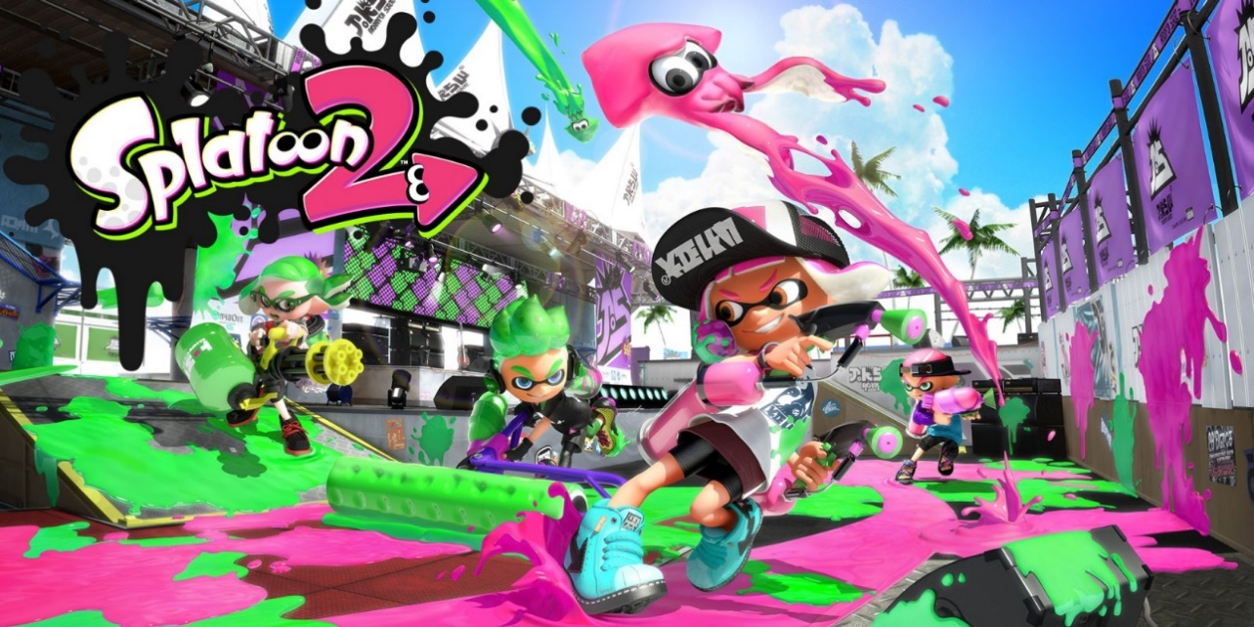](https://www.nintendo.co.uk/Games/Nintendo-Switch/Splatoon-2-1173295.html)

This game is Splatoon developed by Nintendo as an original IP in the game you play as an inkling which can stay as a human-ish form and then can turn into a squid which can swim in the ink you shoot. The aim of the game is to shoot your team colours ink across the map while also killing the enemy team by dousing them with your ink. This is different to every other popular FPS as if you compare it to a more realistic game such as Call of Duty: WW2 which is based on the events of World War 2 you will see. In Call of Duty you shoot bullets and the aim of the game is to kill your opponent whereas, in Splatoon you shoot out ink and the main objective in the game is to get the most amount of turf.

First Person Shooters usually don’t contain much story as they focus on online gameplay over everything else however Call of duty: WW2 is different as it follows the story of someone who served in the war to fight against Germany.

[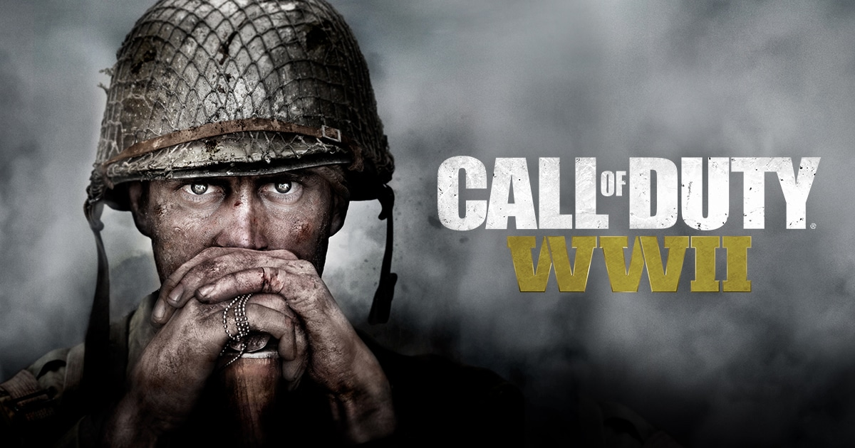](https://www.callofduty.com/uk/en/wwii)

## Role Playing Games (RPG)

Role Playing Games are games that involve the player taking on a role of a fictional character usually in a science-fiction setting an example of this is Pokémon where you play as a young boy or girl and catch, and train pocket monsters called Pokémon. Pokémon is a game series not really known for their story but more for the gameplay whereas Persona 5 is widely known for its great story and music rather than its gameplay so much so that it was recommended for game of the year.

[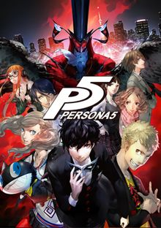](https://en.wikipedia.org/wiki/Persona_5) [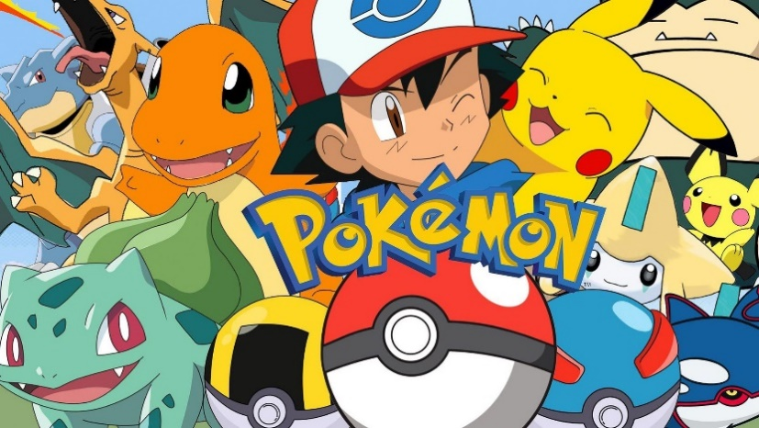](http://www.clubit.tv/2017/08/pokemon-movie-western-release/)

## Fighting

Fighting games involve the player fighting another character by using certain button combination to defeat their opponents by using special moves. The story usually isn’t very detailed in fighting games for example with Mortal Kombat there used to be no story in the games and you just started by selecting a character and then killing your opponent. Whereas, in Super Smash Bros Brawl there is a story mode where you fight your way through hordes of enemies to turn your friends back from trophies.

[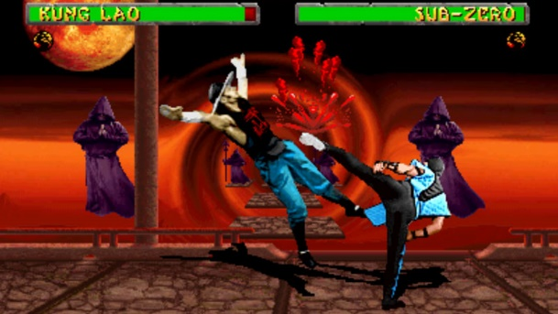](https://www.engadget.com/2007/04/11/mortal-kombat-ii-gets-downloadable-april-12th/) [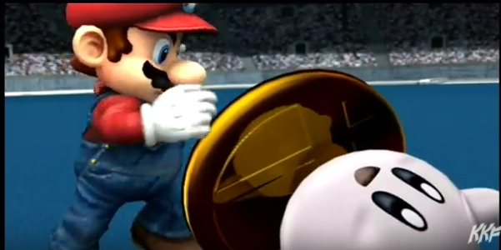](https://www.youtube.com/watch?v=7Xg-sx9YxRo)

## Sport

The sport genre in games is widely popular due to the game series FIFA in these games you play a specific sport usually online against other people. These types of games don’t usually rely on story and it is usually never the main part of the game such as FIFA they focus on gameplay and realism over their story mode which is just match after match with no real characterisation and story developing and this is because FIFA focuses on controlling a football team, so you can’t play as just one team member and build up their story. Whereas Nintendo new game Mario Tennis: Aces which is soon to be released will focus on a story mode where there will be a variety of missions and boss battles.

[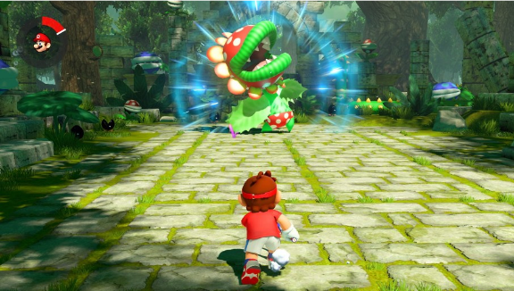](http://www.usgamer.net/articles/mario-tennis-aces-story-mode-sports-opinion) [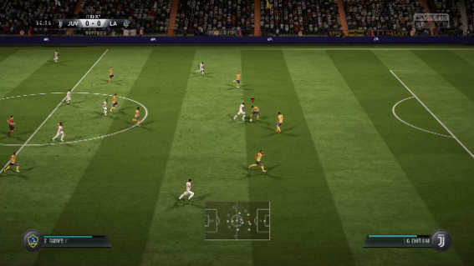](http://www.usgamer.net/articles/26-01-2018-fifa-18-best-young-players-fifa-18-players-with-highest-potential-how-to-judge-potential/fifa-18-the-best-young-players-gk-cb-rb-lb)

## Strategy

Strategy games again usually focus on gameplay over anything else however they usually do always have a decent story. Most games of the genre aim for realism an example of this is Civilisation 6 as their story mode replicates the map of the world and you select which empire you want to be and try and conquer the world.

However, some strategy games such as Mario + Rabbids Kingdom Battle tell a peculiar story in a fantasy setting as this game brings the rabid bunnies "Rabbids" into the Mushroom Kingdom to cause havoc to Mario and his friends.

[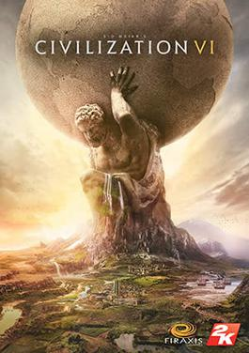](https://en.wikipedia.org/wiki/Civilization_VI)[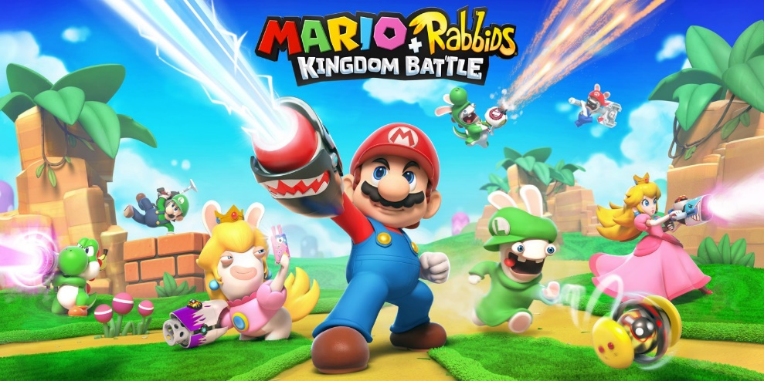](https://www.nintendo.co.uk/Games/Nintendo-Switch/Mario-Rabbids-Kingdom-Battle-1233954.html)

## Simulation

Simulation games never really have that much story as the player is usually dropped into a random scenario and are put to work. For example, in the game Super-Hot it starts off with someone charging towards you with a knife and that is it once you defeat the charging enemy you are dropped off in front of two enemies and then the game continues to escalate.

[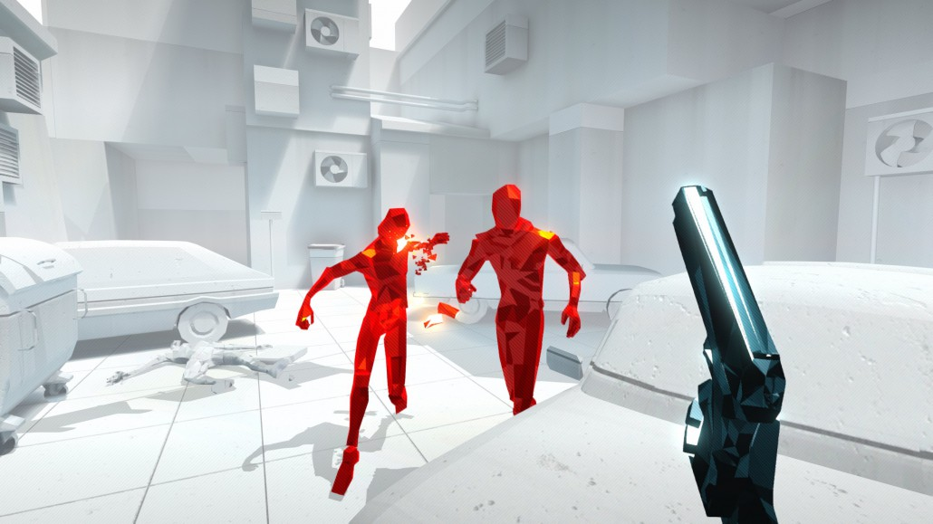](https://superhotgame.com/)

An example of a simulation game which has a story is Abzu it is a swimming simulator made for Virtual Reality (VR) the general concept of the story is that you are an adventurer who has always had a dream of diving into the depths of the ocean and finding new sea life.

[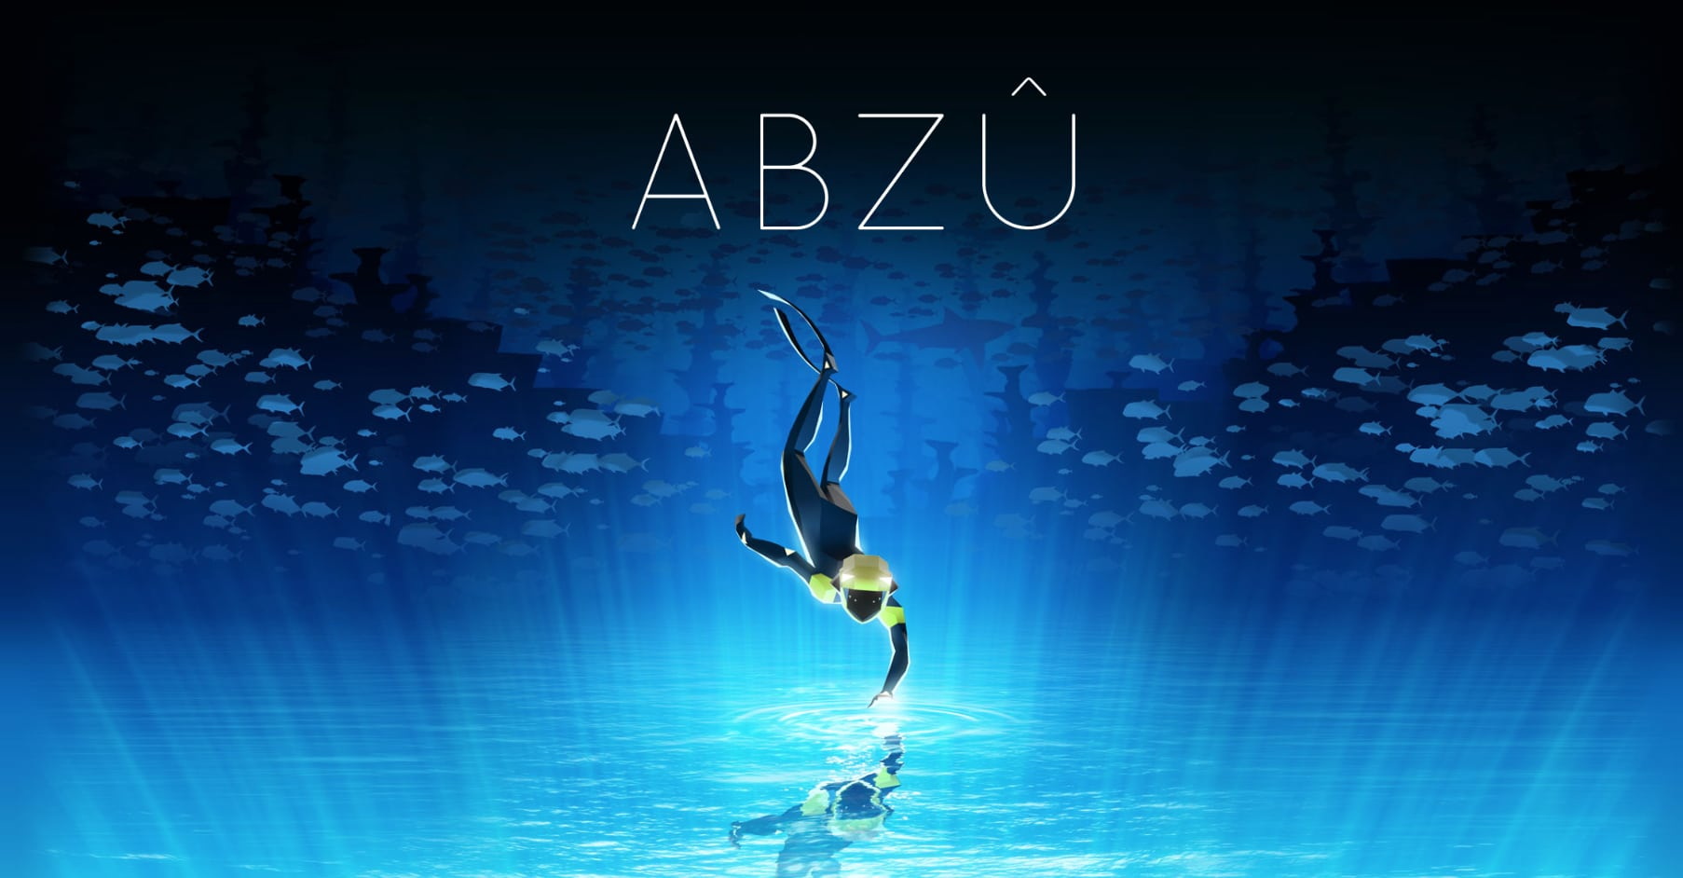](https://www.deeperblue.com/new-diving-video-game-coming-soon/)

# Story Devices

## Location

The location of a game/story is important as it defines the overall story and the limitations of what can be touched on in the story, such as how big the world is, and this effects how much your character could explore of that world. The location/setting of your story also defines what the player/reader will envision the world around your character to look like, because of this most story writers will be very descriptive to create a vivid image in their reader’s mind. A writer who wants a descriptive story would do this by clearly explaining what is around their character and occasionally zooming in on small details and explaining them further.

## Conditions and Actions

[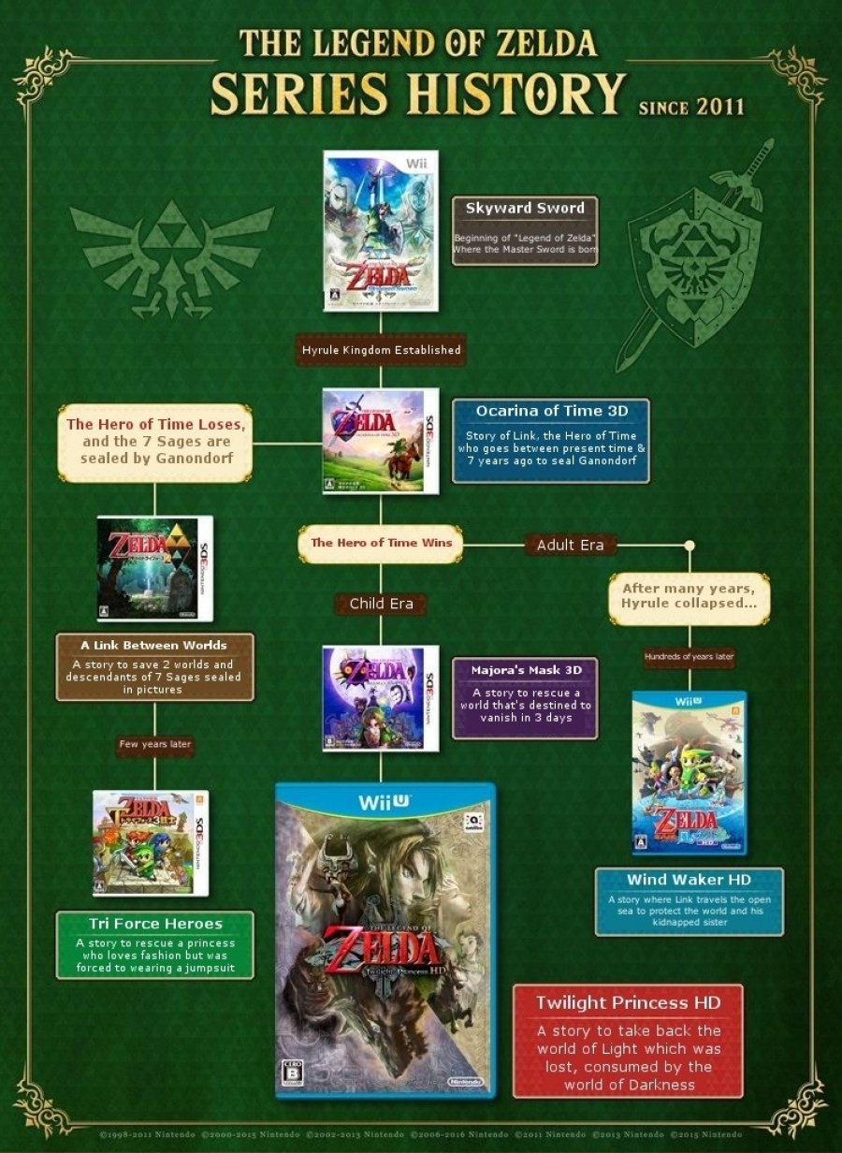](http://www.nintendolife.com/news/2016/01/the_official_legend_of_zelda_timeline_has_been_updated)The conditions of a story basically mean the idea of cause and effect meaning that every action has an impact on the general story. A perfect example of this is in the game series the Legend of Zelda and the idea is that in the game Ocarina of time the main character link can turn into an adult or stay as a child and whether or not which option you pick makes it so that the next game in the series is different, for example if the main character stays as a child and defeats the evil lord “Ganon” the next game in the series will be Majora’s Mask.

Actions are things that were affected by the character this also relates back to the cause and effect idea. An example of this is again with the Zelda game series and has to do with the same theory as the main character’s action of defeating Ganon or not changes the story.

## Symbolism

Symbolism is usually used to represent emotion in unusual ways such as sun representing happiness and rain depression or sorrow. An example of symbolism used in a game is from the wonderful platformer Celeste as the game deals with a girl’s depression and panic attacks and when the main character is feeling depressed it rains heavily or becomes very windy while also being dark whereas at the end of the game when the girl gets over her depression the sky becomes vibrant with fluffy clouds to show that she is happy.

[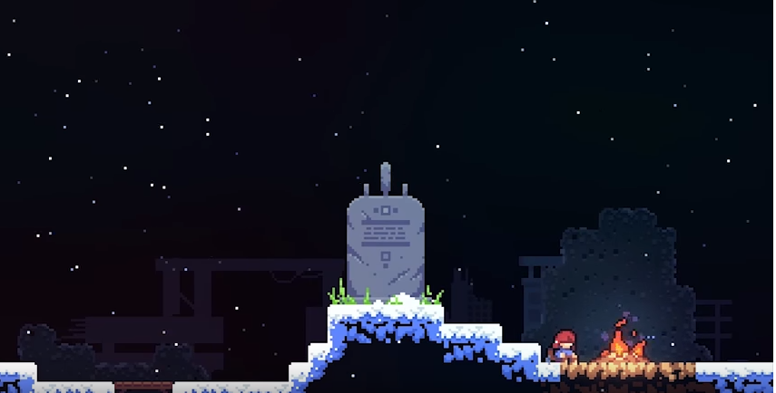](https://www.youtube.com/watch?v=qHLizp8fARo)[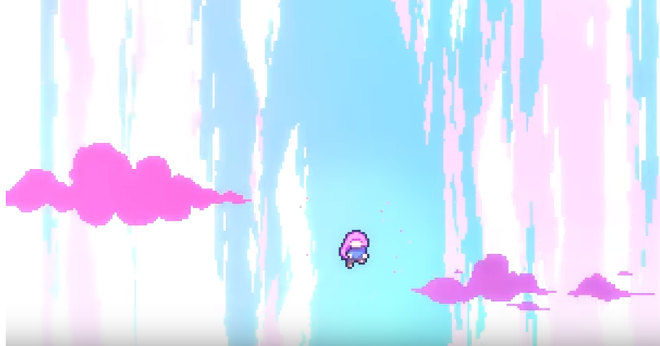](https://www.youtube.com/watch?v=V0F4sp2GCdA)

## Three Act Structure

The three-act structure is a basic form of storytelling that many game developers follow. It describes the three stages to storytelling the basic beginning, middle and end. The beginning starts off with introducing the main characters, the setting and the basics of the plot for the world that the story is based in for example if there is an evil king that you must defeat.

Secondly, you have the middle this is where the story develops, and you learn the back story of your main character and the true intentions of the villain of the game/story. New characters could be introduced to the story adding more to the plot of a story.

The third and final stage in the story usually concludes every plot point and key story development, for example Mario defeats Bowser and recues Princess Peach. However, most games now like in tv-shows end on a cliff hanger to be resolved in the next game in the series.

An example of a game with a three-act structure is any game out of the Mario series as it starts off with Bowser stealing the princess. Secondly, in the middle of the game you fight the boss Bowser and then he tells you his evil plan. Thirdly, you fight Bowser again win and then rescue the princess.

[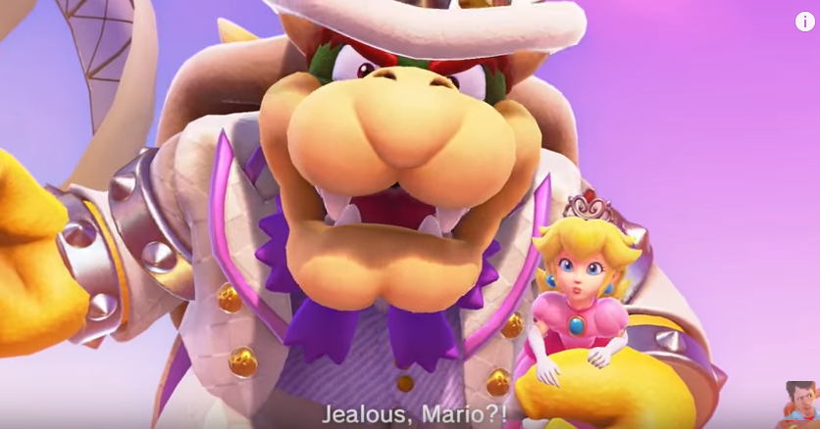](https://www.youtube.com/watch?v=CzzvOv8Scx4)[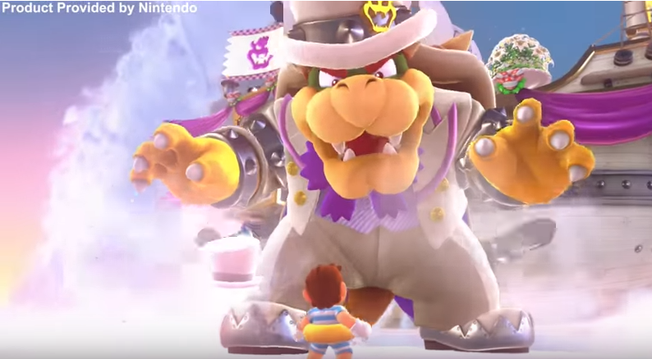](https://www.youtube.com/watch?v=BnNIJFK07Vg)[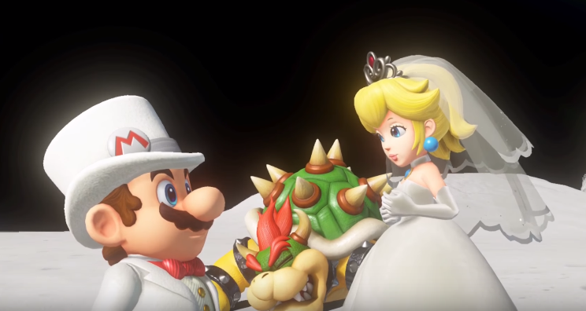](https://www.youtube.com/watch?v=wfNl38NhDbk)

## Hero’s Journey

The hero’s journey is an idea for a basic structure of telling a story with a hero. To explain each step, I will use The Karate Kid as an example, bear in mind that these steps are not exact as they change with everyone. Firstly, the potential hero is introduced in a normal setting and then something happens to the main character where they are put out of there comfort zone, for example with Karate Kid the main character moves home where he has to say goodbye to all his friends and family.

Secondly the main character is met with a challenge which he must overcome later in the story, in Karate Kid the main character gets bullied.

Thirdly the main character learns how to overcome their challenge such as in Karate Kid the main character learns that he must learn Karate to defeat his bully in a competition.

Fourthly the character trains or gets a mentor to eventually overcome their challenge. For example, with Karate Kid the main character finds a mentor and learns how to fight.

Finally, the main character uses their training to overcome the challenge and everything is resolved as in Karate Kid the main character defeats his bully in a Karate competition.

[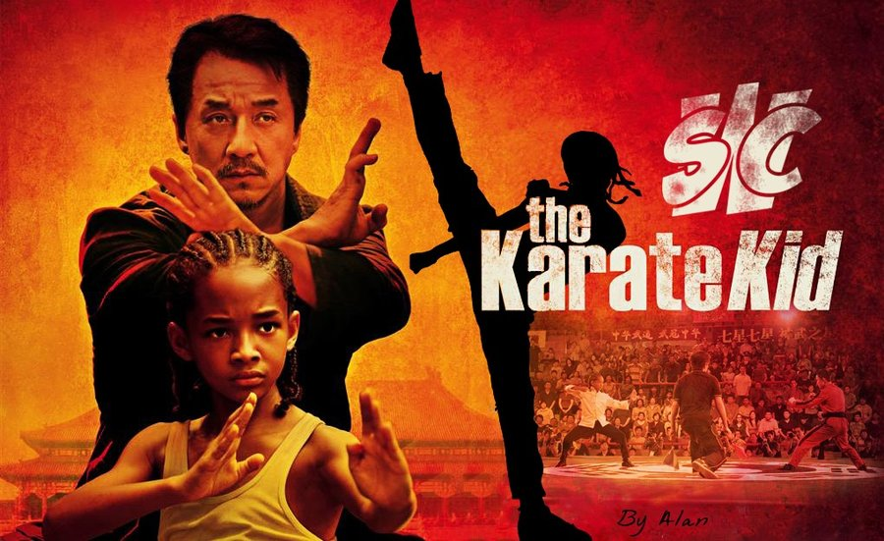](https://alandchaves.deviantart.com/art/The-Karate-Kid-Sept-2010-204358035)

## Episodic

Episodic is when in the example of games everything is set in the same universe and world it’s just that you can play any of the games set in the same world without playing or knowing anything about the other games. For an example I will use the Pokémon game franchise as in this they are all set in the same world with the same Pokémon in each game but every time you start a new game it explains what Pokémon are, the world and how to play the game.

[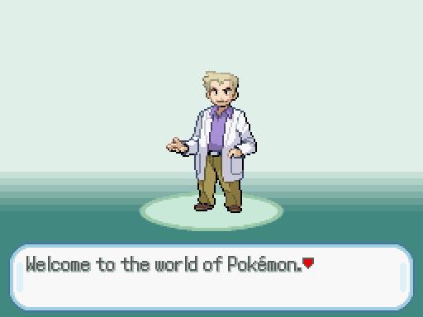](http://pokemonessentials.wikia.com/wiki/Game_intro)

# Representation

## Emotion

Emotions are key to developing characters within a story, they create a connection between the player and the characters which further develop the story. Without emotions being added to storytelling within games and tv-shows the portrayals of characters would become dry and boring.

A good example of emotion used properly is in the television show Limitless it is about a random guy who starts taking a drug called NZT that makes him smart, so he starts working for the FBI, in this show the main character Brian Finch displays emotions to the fullest which creates a connection between him and the audience so that when he displays sadness you feel empathy for him.

[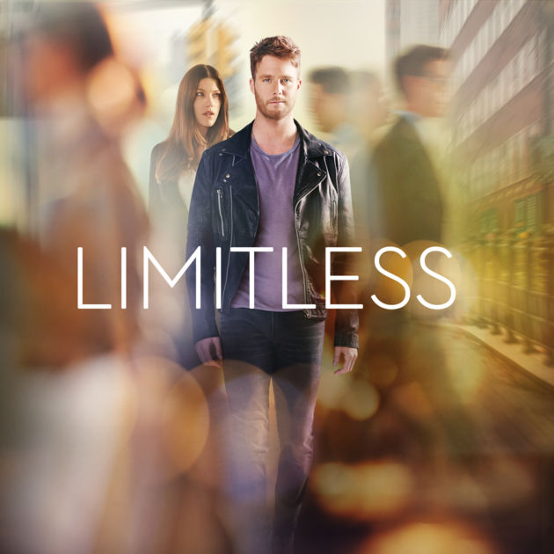](https://itunes.apple.com/us/tv-season/limitless-season-1/id1031572562)

## Characterisation

Characterisation is what the character looks like, what defines their actions and what they love meaning that it is greatly needed in order have a full fleshed out character making them seem more realistic. Characterisation can also be practical for example in the game celeste the main character Madeline has red hair and when she uses her dash ability her hair turns blue and you can no longer dash until you touch the ground and her hair turns bac to red. This shows that characterisation can add to the gameplay as well as the story.

[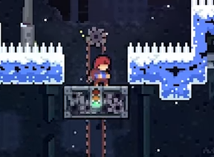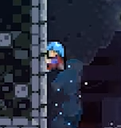](https://www.youtube.com/watch?v=qHLizp8fARo)

## Stereotyping

Stereotyping used to be a problem in the early stages of gaming’s history as most games were sexist towards woman and most still oversexualise them today. The reason for this being an ethical consideration is because usually when a female is in a video game they are sexualised. This is not really a problem nowadays but still woman in video games are still sexualised for example nearly every female character in the game Overwatch is wearing a skin-tight costume such as with the characters Tracer and Widow. With the picture below of the character Tracer there was a lot of controversy as when the game was first released one of Tracers’ emotes was too sexualised this is the one which faces her back, this was then changed to the other emote because people complained that it was too sexual. From this I have learnt that I should treat Females and makes the same in games and not overly sexualise characters in the game I make.

[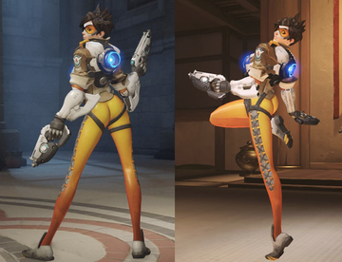](https://en.wikipedia.org/wiki/Tracer_(Overwatch))[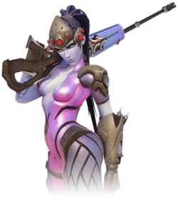](https://en.wikipedia.org/wiki/Widowmaker_(Overwatch))

# Resources

<https://elementsofstorytelling.wordpress.com/2012/10/14/forms-of-storytelling/>

<https://writingcooperative.com/five-forms-of-storytelling-d576d5e3f5bb>

<https://jimmyworkman.wordpress.com/year-13/fmp-choices/unit-74-computer-game-story-development/unit-74-task-1/>

<http://u74mb.blogspot.co.uk/2017/02/task-1.html>

<https://www.youtube.com/watch?v=8VlyAb2qaGI>

<https://www.youtube.com/watch?v=1rMnzNZkIX0>

<http://quals.onefile.co.uk/pdf/unit/CMP3_074.pdf> Specification